Chapter 05. Implementing Social Authentication

In the previous chapter, you built user registration and authentication into your website. You implemented password change, reset, and recovery functionalities, and you learned how to create a custom profile model for your users.

In this chapter, you will add social authentication to your site using Google. You will use Python Social Auth for Django to implement social authentication using OAuth 2.0, the industry-standard protocol for authorization. You will also modify the social authentication pipeline to create a user profile for new users automatically.

This chapter will cover the following points:

- Using the messages framework
- Building a custom authentication backend
- Preventing users from using an existing email
- Adding social authentication with Python Social Auth
- Running the development server through HTTPS using Django Extensions
- Adding authentication using Google
- Creating a profile for users that register with social authentication

Functional overview
Figure 5.1 shows a representation of the views, templates, and functionalities that will be built in this chapter:
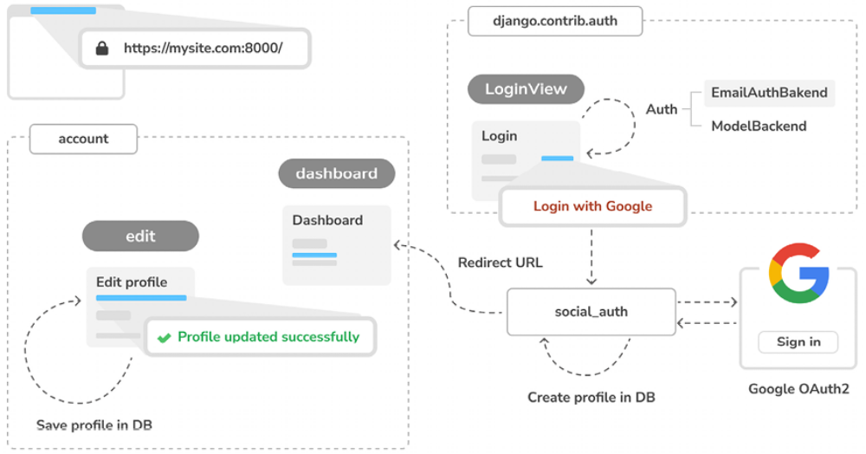
Figure 5.1: Diagram of functionalities built in Chapter 5

In this chapter, you will generate success and error messages in the edit view using the Django messages framework. You will build a new authentication backend named EmailAuthBackend for users to authenticate using their email addresses. You will serve your site over HTTPS during development using Django Extensions, and you will implement social authentication with Google on your site using Python Social Auth. Users will be redirected to the dashboard view after successful authentication. You will customize the authentication pipeline to create user profiles automatically when a new user is created with social authentication.

Technical requirements
The source code for this chapter can be found at
https://github.com/PacktPublishing/Django-5-byexample/tree/main/Chapter05.

All Python packages used in this chapter are included in the requirements.txt file in the source code for the chapter. You can follow the instructions to install each Python package in the following sections, or you can install all requirements at once with the python -m pip install -r requirements.txt command.

Using the messages framework
When users are interacting with the platform, there are many cases where you might want to inform them about the result of specific actions, such as successfully creating an object in the database or successfully submitting a form.

Django has a built-in messages framework that allows you to display onetime notifications to your users. This enhances user experience by providing immediate feedback on their actions, making the interface more intuitive and user friendly.

The messages framework is located at django.contrib.messages and is included in the default INSTALLED_APPS list of the settings.py file when you create new projects using python manage.py startproject . The settings file also contains the django.contrib.messages.middleware.MessageMiddleware middleware in the MIDDLEWARE setting.

The messages framework provides a simple way to add messages to users. Messages are stored in a cookie by default (falling back to session storage), and they are displayed and cleared in the next request from the user. You can use the messages framework in your views by importing the messages module and adding new messages with simple shortcuts, as follows:
from django.contrib import messages
messages.error(request, 'Something went wrong')

You can create new messages using the add_message() method or any of the following shortcut methods:
- success() : Success messages are used to display when an action was successful

- info() : Informational messages

- warning() : This shows that a failure has not yet occurred but it may be imminent

- error() : This shows that an action was not successful or a failure occurred

- debug() : This shows debug messages that will be removed or ignored in a production environment

Let’s add messages to the project. The messages framework applies globally to the project. We will use the base template to display any available messages to the client. This will allow us to notify the client of the results of any action on any page.
Open the templates/base.html template of the account application and add the following code highlighted in bold:
{% load static %}
<!DOCTYPE html>
<html>
<head>
<title>{% block title %}{% endblock %}</title>
<link href="{% static "css/base.css" %}" rel="stylesheet">
</head>
<body>
<div id="header">
...
</div>
{% if messages %}
<ul class="messages">
{% for message in messages %}
<li class="{{ message.tags }}">
{{ message|safe }}
<a href="#" class="close">x</a>
</li>
{% endfor %}
</ul>
{% endif %}
<div id="content">
{% block content %}
{% endblock %}
</div>
</body>
</html>

The messages framework includes thedjango.contrib.messages.context_processors.messages context processor, which adds a messages variable to the request context. You can find it in the
context_processors list in the TEMPLATES setting of your project. You can use the messages variable in templates to display all existing messages to the user.


A context processor is a Python function that takes the
request object as an argument and returns a dictionary that
gets added to the request context. You will learn how to
create your own context processors in Chapter 8, Building
an Online Shop.



Let’s modify the edit view to use the messages framework.

Edit the views.py file of the account application and add the following lines highlighted in bold:
from django.contrib import messages
# ...
@login_required
def edit(request):
if request.method == 'POST':
user_form = UserEditForm(
instance=request.user,
data=request.POST
)
profile_form = ProfileEditForm(
instance=request.user.profile,
data=request.POST,
files=request.FILES
)
if user_form.is_valid() and profile_form.is_valid():
user_form.save()
profile_form.save()
messages.success(
request,
'Profile updated successfully'
)
else:
messages.error(request, 'Error updating your profile
else:
user_form = UserEditForm(instance=request.user)
profile_form = ProfileEditForm(
instance=request.user.profil
return render(
request,
'account/edit.html',
{'user_form': user_form, 'profile_form': profile_form}
)

A success message is generated when users successfully update their profile. If any of the forms contain invalid data, an error message is generated instead.

Open http://127.0.0.1:8000/account/edit/ in your browser and edit the profile of the user. You should see the following message when the profile is successfully updated:
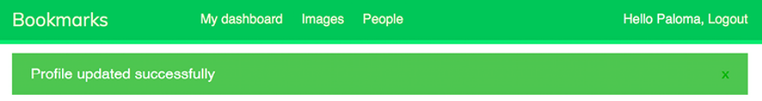
Figure 5.2: The successfully edited profile message

Enter an invalid date in the Date of birth field and submit the form again.You should see the following message:
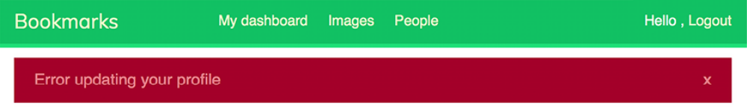
Figure 5.3: The error updating profile message

Generating messages to inform your users about the results of their actions is straightforward. You can easily add messages to other views as well.

You can learn more about the messages framework at
https://docs.djangoproject.com/en/5.0/ref/contrib/messages/.

Now that we’ve built all the functionality related to user authentication and profile editing, we will dig deeper into customizing authentication. We will learn how to build custom backend authentication so that users can log in to the site using their email addresses.

Building a custom authentication backend
Django allows you to authenticate users against different sources, such as the built-in Django authentication system, external authentication systems like Lightweight Directory Access Protocol (LDAP) servers, or even thirdparty providers. The AUTHENTICATION_BACKENDS setting includes a list of authentication backends available in the project. Django enables you to specify multiple authentication backends for flexible authentication schemes. The default value of the AUTHENTICATION_BACKENDS setting is the following:
['django.contrib.auth.backends.ModelBackend']

The default ModelBackend authenticates users against the database using the User model of django.contrib.auth . This is suitable for most web projects. However, you can create custom backends to authenticate your users against other sources.

You can read more information about customizing authentication at
https://docs.djangoproject.com/en/5.0/topics/auth/customizing/#other-authentication-sources.

Whenever the authenticate() function of django.contrib.auth is used, Django tries to authenticate the user against each of the backends defined in AUTHENTICATION_BACKENDS one by one, until one of them successfully authenticates the user. Only if all of the backends fail to authenticate will the user not be authenticated.

Django provides a simple way to define your own authentication backends.

An authentication backend is a class that provides the following two methods:

- authenticate() : It takes the request object and user credentials as parameters. It has to return a user object that matches those credentials if the credentials are valid, or None otherwise. The request parameter is an HttpRequest object, or None if it’s not provided to the authenticate() function.

- get_user() : It takes a user ID parameter and has to return a user object.

Creating a custom authentication backend is as simple as writing a Python class that implements both methods. Let’s create an authentication backend to allow users to authenticate on the site using their email address instead of their username.

Create a new file inside the account application directory and name it authentication.py . Add the following code to it:
from django.contrib.auth.models import User
class EmailAuthBackend:
"""
Authenticate using an e-mail address.
"""
def authenticate(self, request, username=None, password=None):
try:
user = User.objects.get(email=username)
if user.check_password(password):
return user
return None
except (User.DoesNotExist, User.MultipleObjectsReturned):
return None
def get_user(self, user_id):
try:
return User.objects.get(pk=user_id)
except User.DoesNotExist:
return None

The preceding code is a simple authentication backend. The authenticate() method receives a request object and the username and password optional parameters. We could use different parameters, but we use username and password to make our backend work with the authentication framework views right away. The preceding code works as follows:
authenticate() : The user with the given email address is retrieved, and the password is checked using the built-in check_password() method of the user model. This method handles the password hashing to compare the given password with the password stored in the database. Two different QuerySet exceptions are captured: DoesNotExist and

- MultipleObjectsReturned . The DoesNotExist exception is raised if no user is found with the given email address. The MultipleObjectsReturned exception is raised if multiple users are found with the same email address. We will modify the registration and edit views later to prevent users from using an existing email address.

- get_user() : You get a user through the ID provided in the user_id parameter. Django uses the backend that authenticated the user to retrieve the User object for the duration of the user session. pk is a short for primary key, which is a unique identifier for each record in the database. Every Django model has a field that serves as its primary key. By default, the primary key is the automatically generated ID field.

You can find more information about automatic primary key fields at
https://docs.djangoproject.com/en/5.0/topics/db/models/#automatic-primary-key-fields.

Edit the settings.py file of your project and add the following code:
AUTHENTICATION_BACKENDS = [
'django.contrib.auth.backends.ModelBackend',
'account.authentication.EmailAuthBackend',
]

In the preceding setting, we keep the default ModelBackend that is used to authenticate with the username and password and include our own emailbasedauthentication backend EmailAuthBackend .

Open http://127.0.0.1:8000/account/login/ in your browser. Remember that Django will try to authenticate the user against each of the backends, so now you should be able to log in seamlessly using your username or email account.

The user credentials will be checked using ModelBackend , and if no user is returned, the credentials will be checked using EmailAuthBackend .


The order of the backends listed in the
AUTHENTICATION_BACKENDS setting matters. If the same
credentials are valid for multiple backends, Django will
authenticate the user using the first backend in the list that
successfully validates these credentials. This means Django
does not proceed to check the remaining backends once a
match is found.

Preventing users from using an existing email address
The User model of the authentication framework does not prevent creating users with the same email address. If two or more user accounts share the same email address, we won’t be able to discern which user is authenticating. Now that users can log in using their email address, we have to prevent users from registering with an existing email address.

We will now change the user registration form to prevent multiple users from registering with the same email address.

Edit the forms.py file of the account application and add the following lines highlighted in bold to the UserRegistrationForm class:
class UserRegistrationForm(forms.ModelForm):
password = forms.CharField(
label='Password',
widget=forms.PasswordInput
)
password2 = forms.CharField(
label='Repeat password',
widget=forms.PasswordInput
)
class Meta:
model = User
fields = ['username', 'first_name', 'email']
def clean_password2(self):
cd = self.cleaned_data
if cd['password'] != cd['password2']:
raise forms.ValidationError('Passwords don\'t match.
return cd['password2']
def clean_email(self):
data = self.cleaned_data['email']
if User.objects.filter(email=data).exists():
raise forms.ValidationError('Email already in use.')
return data

We have added validation for the email field that prevents users from registering with an existing email address. We build a QuerySet to look up existing users with the same email address. We check whether there are any results with the exists() method. The exists() method returns True if the QuerySet contains any results, and False otherwise.

Now, add the following lines highlighted in bold to the UserEditForm class:
class UserEditForm(forms.ModelForm):
class Meta:
model = User
fields = ['first_name', 'last_name', 'email']
def clean_email(self):
data = self.cleaned_data['email']
qs = User.objects.exclude(
id=self.instance.id
).filter(
email=data
)
if qs.exists():
raise forms.ValidationError('Email already in use.')
return data

In this case, we have added validation for the email field that prevents users from changing their existing email address to an existing email address of another user. We exclude the current user from the QuerySet. Otherwise, the current email address of the user would be considered an existing email address, and the form won’t validate.

Adding social authentication to your site
Social authentication is a widely used feature that allows users to authenticate using their existing account of a service provider using single sign-on (SSO). The authentication process allows users to authenticate into the site using their existing account from social services like Google, Facebook, or Twitter. In this section, we will add social authentication to the site using Google.

To implement social authentication, we will use the OAuth 2.0 industrystandard protocol for authorization. OAuth stands for Open Authorization. OAuth 2.0 is a standard designed to allow a website or application to access resources hosted by other web apps on behalf of a user. Google uses the OAuth 2.0 protocol for authentication and authorization.

Python Social Auth is a Python module that simplifies the process of adding social authentication to your website. Using this module, you can let your users log in to your website using their accounts from other services. You can find the code for this module at https://github.com/pythonsocial-auth/social-app-django.

This module comes with authentication backends for different Python frameworks, including Django.

Run the following command in the shell:
python -m pip install social-auth-app-django==5.4.0

This will install Python Social Auth.

Then, add social_django to the INSTALLED_APPS setting in the settings.py file of the project as follows:
INSTALLED_APPS = [
# ...
'social_django',
]

This is the default application to add Python Social Auth to Django projects.
Now, run the following command to sync Python Social Auth models with your database:
python -m python manage.py migrate

You should see that the migrations for the default application are applied as follows:
Applying social_django.0001_initial... OK
...
Applying social_django .0015_rename_extra_data_new_usersocialauth

Python Social Auth includes authentication backends for multiple services. You can find the list with all available backends at https://pythonsocialauth.readthedocs.io/en/latest/backends/index.html#supported-backends.

We will add social authentication to our project, allowing our users to authenticate with the Google backend.

First, we need to add the social login URL patterns to the project.

Open the main urls.py file of the bookmarks project and include the social_django URL patterns as follows. The new lines are highlighted in
bold:
urlpatterns = [
path('admin/', admin.site.urls),
path('account/', include('account.urls')),
path(
'social-auth/',
include('social_django.urls', namespace='social')
),
]

Our web application is currently accessible via the localhost IP, 127.0.0.1 , or using the localhost hostname. Google allows the redirection of users to localhost after successful authentication, but other social services expect a domain name for the URL redirect. In this project, we will simulate a real environment by serving our site under a domain name in our local machine.

Locate the hosts file of your machine. If you are using Linux or macOS, the hosts file is located at /etc/hosts . If you are using Windows, the hosts file is located at C:\Windows\System32\Drivers\etc\hosts .

Edit the hosts file of your machine and add the following line to it:
127.0.0.1 mysite.com

This will tell your computer to point the mysite.com hostname to your own machine.

Let’s verify that the hostname association worked. Run the development server using the following command from the shell prompt:
python manage.py runserver

Open http://mysite.com:8000/account/login/ in your browser. You will see the following error:
Figure 5.4: The invalid host header message

Django controls the hosts that can serve the application using the ALLOWED_HOSTS setting. This is a security measure to prevent HTTP host header attacks. Django will only allow the hosts included in this list to serve the application.
You can learn more about the ALLOWED_HOSTS setting at
https://docs.djangoproject.com/en/5.0/ref/settings/#allowed-hosts.

Edit the settings.py file of the project and modify the ALLOWED_HOSTS setting as follows. The new code is highlighted in bold:
ALLOWED_HOSTS = ['mysite.com', 'localhost', '127.0.0.1']

Besides the mysite.com host, we have explicitly included localhost and 127.0.0.1 . This allows access to the site through localhost and 127.0.0.1 , which is the default Django behavior when DEBUG is True and ALLOWED_HOSTS is empty.

Open http://mysite.com:8000/account/login/ again in your browser. Now, you should see the login page of the site instead of an error.

Running the development server through HTTPS
Next, we are going to run the development server through HTTPS to simulate a real environment where the content exchanged with the browser is secured. This will help us later in Chapter 6, Sharing Content on Your Website, to serve our site securely and load our image bookmarking tool on top of any secure website. The Transport Layer Security (TLS) protocol is the standard for serving websites through a secure connection. The TLS predecessor is the Secure Sockets Layer (SSL).

Although SSL is now deprecated, you will find references to both the terms TLS and SSL in multiple libraries and online documentation. The Django development server is not able to serve your site through HTTPS since that is not its intended use. To test the social authentication functionality serving the site through HTTPS, we are going to use the RunServerPlus extension of the package Django Extensions. This package contains a collection of useful Django tools. Please note that you should never use the development server to run your site in a production environment.

Use the following command to install Django Extensions:
python -m pip install django-extensions==3.2.3

You will need to install Werkzeug, which contains a debugger layer required by the RunServerPlus extension of Django Extensions. Use the following command to install Werkzeug:
python -m pip install werkzeug==3.0.2

Finally, use the following command to install pyOpenSSL, which is required to use the SSL/TLS functionality of RunServerPlus:
python -m pip install pyOpenSSL==24.1.0

Edit the settings.py file of your project and add Django Extensions to the
INSTALLED_APPS setting, as follows:
INSTALLED_APPS = [
# ...
'django_extensions',
]

Now, use the runserver_plus management command provided by Django Extensions to run the development server, as follows:
python manage.py runserver_plus --cert-file cert.crt

We have provided a file name to the runserver_plus command for the SSL/TLS certificate. Django Extensions will generate a key and certificate automatically.

Open https://mysite.com:8000/account/login/ in your browser. Now, you are accessing your site through HTTPS. Note we are now using https://instead of http:// .

Your browser will show a security warning because you are using a selfgenerated certificate instead of a certificate trusted by a certification authority (CA).

If you are using Google Chrome, you will see the following screen:
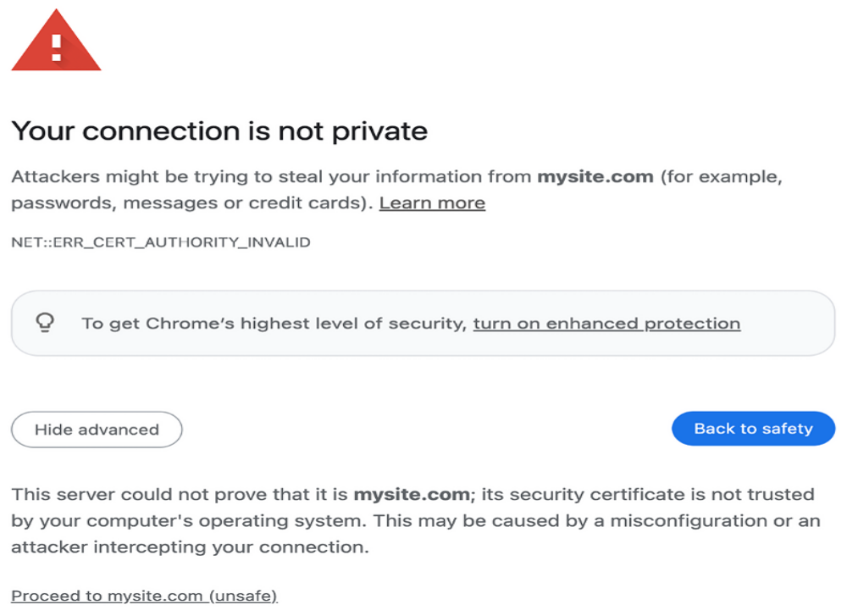
Figure 5.5: The safety error in Google Chrome
In this case, click on Advanced and then click on Proceed to mysite.com (unsafe).

If you are using Safari, you will see the following screen:
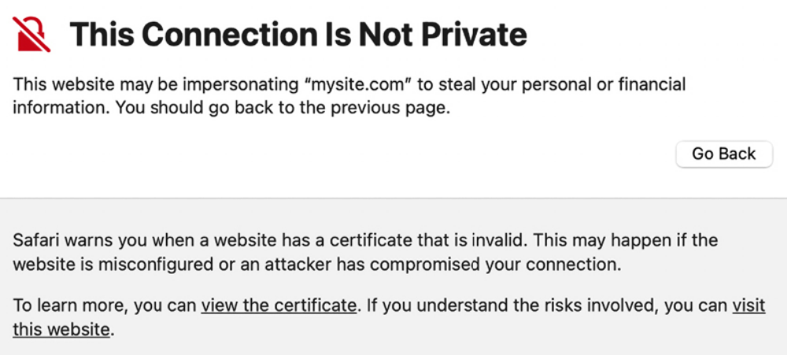
Figure 5.6: The safety error in Safari

In this case, click on Show details and then click on visit this website.

If you are using Microsoft Edge, you will see the following screen:
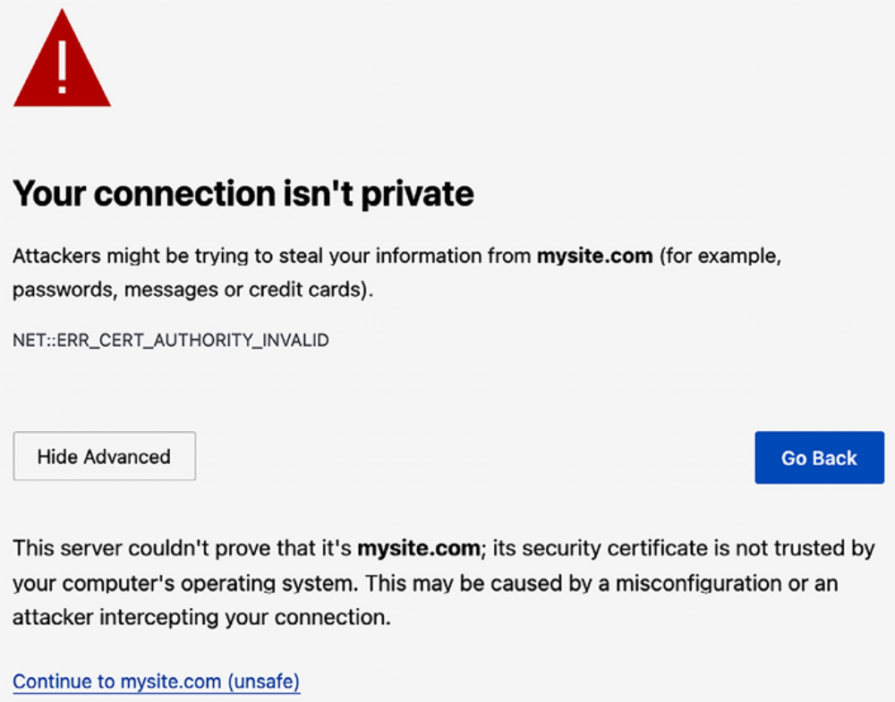
Figure 5.7: The safety error in Microsoft Edge

In this case, click on Advanced and then on Continue to mysite.com (unsafe).

If you are using any other browser, access the advanced information displayed by your browser and accept the self-signed certificate so that your browser trusts the certificate.

You will see that the URL starts with https:// and, in some cases, a lock icon that indicates that the connection is secure. Some browsers might display a broken lock icon because you are using a self-signed certificate instead of a trusted one. That won’t be a problem for our tests:
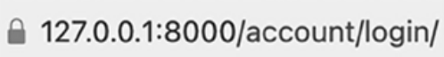
Figure 5.8: The URL with the secured connection icon


Django Extensions includes many other interesting tools and
features. You can find more information about this package
at https://djangoextensions.readthedocs.io/en/latest/.

You can now serve your site through HTTPS during development.

Authentication using Google
Google offers social authentication using OAuth 2.0, which allows users to sign in with Google accounts. You can read about Google’s OAuth2 implementation at
https://developers.google.com/identity/protocols/OAuth2.

To implement authentication using Google, add the following line highlighted in bold to the AUTHENTICATION_BACKENDS setting in the settings.py file of your project:
AUTHENTICATION_BACKENDS = [
'django.contrib.auth.backends.ModelBackend',
'account.authentication.EmailAuthBackend',
'social_core.backends.google.GoogleOAuth2',
]

First, you will need to create an API key in your Google Developer Console.

Open https://console.cloud.google.com/projectcreate in your browser. You will see the following screen:
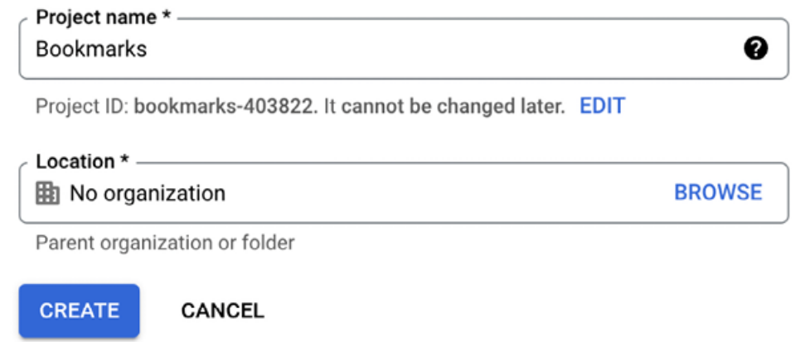
Figure 5.9: The Google project creation form

Under Project name, enter Bookmarks and click the CREATE button.

When the new project is ready, make sure the project is selected in the top
navigation bar as follows:

Figure 5.10: The Google Developer Console top navigation bar

After the project is created, under APIs & Services, click on Credentials:
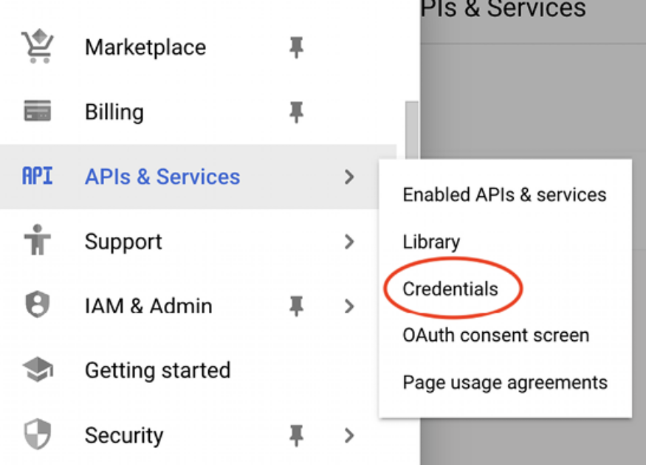
Figure 5.11: Google APIs and services menu

You will see the following screen:
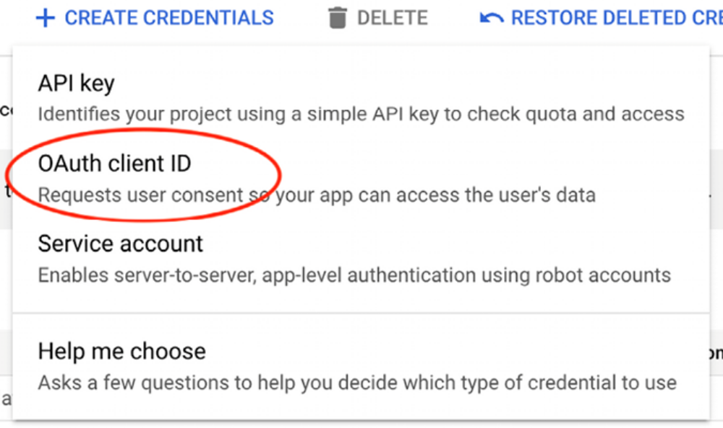
Figure 5.12: Google API creation of API credentials

Then, click on CREATE CREDENTIALS and click on OAuth client ID.

Google will ask you to configure the consent screen first, like this:
Figure 5.13: The alert to configure the OAuth consent screen

We will configure the page that will be shown to users to give their consent to access your site with their Google account. Click on the CONFIGURE CONSENT SCREEN button. You will be redirected to the following screen:
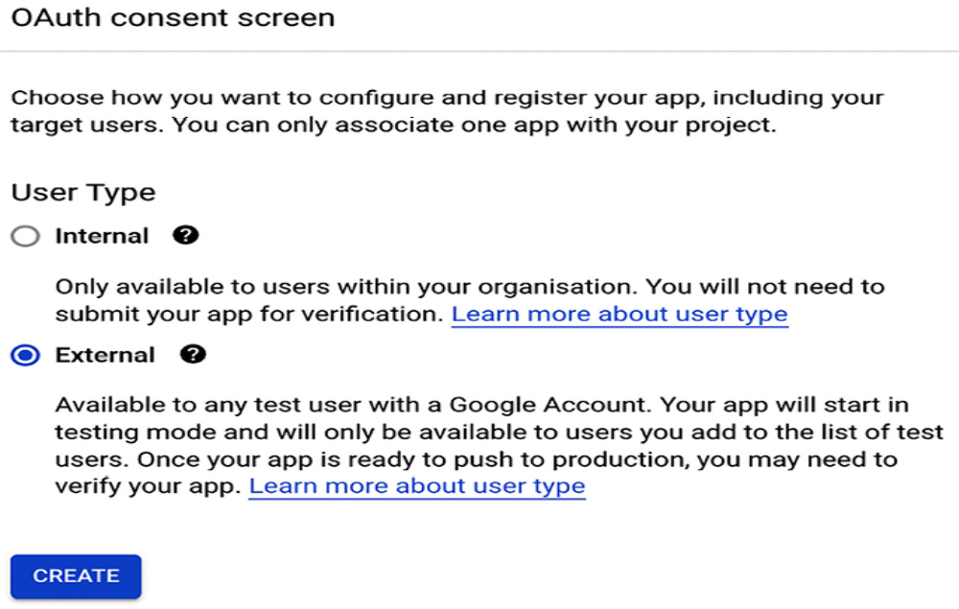
Figure 5.14: The User Type selection in the Google OAuth consent screen setup
Choose External for User Type and click the CREATE button. You will see the following screen:
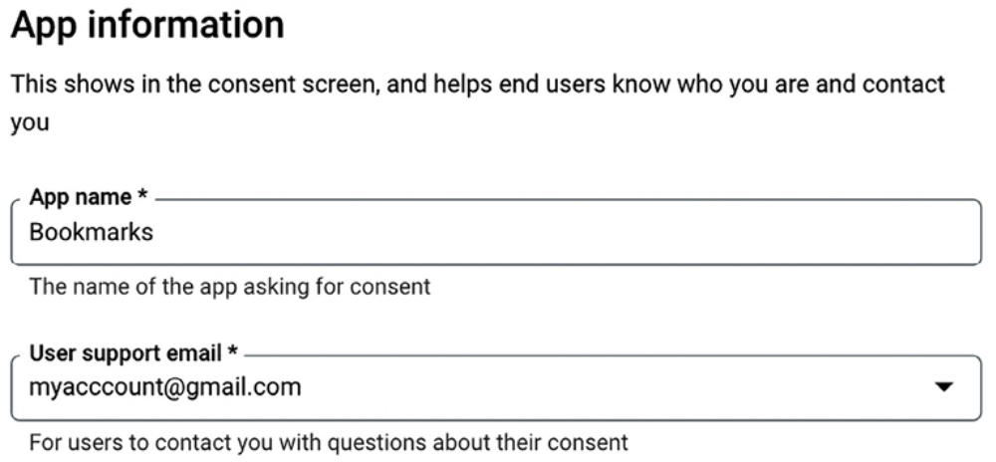
Figure 5.15: The Google OAuth consent screen setup
Under App name, enter Bookmarks and select your email for User support email.

Under Authorised domains, enter mysite.com as follows:
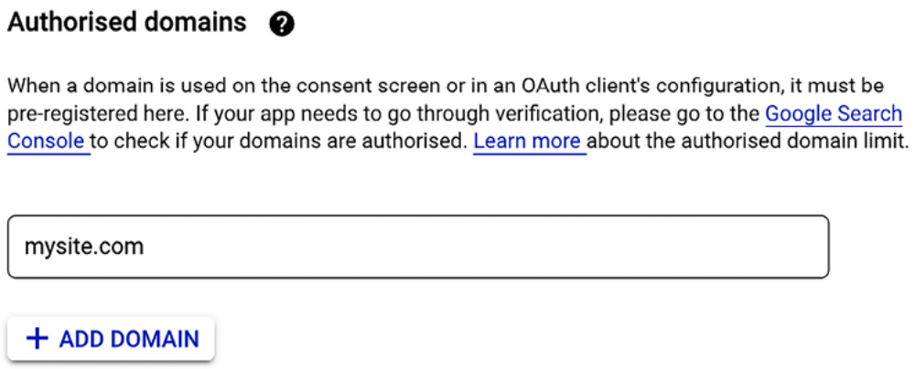
Figure 5.16: Google OAuth authorized domains

Enter your email under Developer contact information and click on SAVE AND CONTINUE.

In step 2, Scopes, don’t change anything and click on SAVE AND CONTINUE.

In step 3, Test users, add your Google user to Test users and click on SAVE AND CONTINUE as follows:
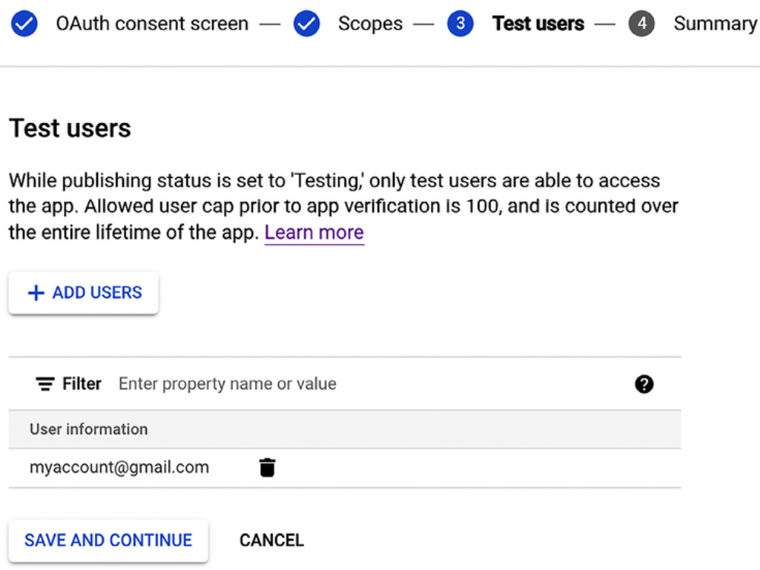
Figure 5.17: Google OAuth test users

You will see a summary of your consent screen configuration. Click on BACK TO DASHBOARD.

In the menu on the left sidebar, click on Credentials, click again on Create credentials, and then on OAuth client ID.

As the next step, enter the following information:

- Application type: Select Web application
- Name: Enter Bookmarks
- Authorised JavaScript origins: Add https://mysite.com:8000
- Authorised redirect URIs: Add https://mysite.com:8000/socialauth/complete/google-oauth2/

The form should look like this:
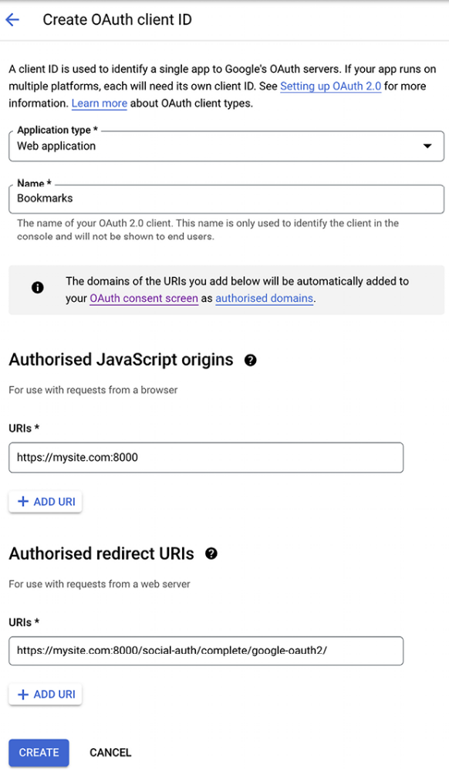
Figure 5.18: The Google OAuth client ID creation form

Click the CREATE button. You will get the Client ID and Client secret keys:
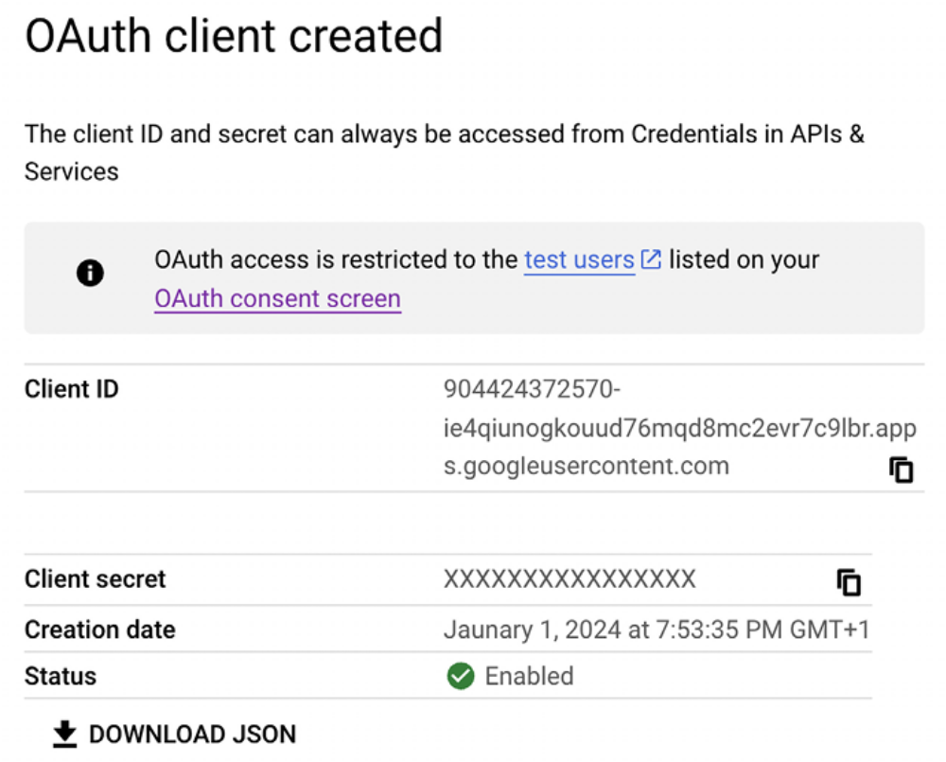
Figure 5.19: Google OAuth – Client ID and Client secret

Create a new file inside your project’s root directory and name it .env . The .env file will contain key-value pairs of environment variables. Add the OAuth2 credentials to the new file, as follows:
GOOGLE_OAUTH2_KEY=xxxx
GOOGLE_OAUTH2_SECRET=xxxx

Replace xxxx with the OAuth2 key and secret respectively.

To facilitate the separation of configuration from code, we are going to use python-decouple . You already used this library in Chapter 2, Enhancing Your Blog and Adding Social Features.

Install python-decouple via pip by running the following command:
python -m pip install python-decouple==3.8

Edit the settings.py file of your project and add the following code to it:
from decouple import config
# ...
SOCIAL_AUTH_GOOGLE_OAUTH2_KEY = config('GOOGLE_OAUTH2_KEY')
SOCIAL_AUTH_GOOGLE_OAUTH2_SECRET = config('GOOGLE_OAUTH2_SECRET'

The SOCIAL_AUTH_GOOGLE_OAUTH2_KEY and SOCIAL_AUTH_GOOGLE_OAUTH2_SECRET settings are loaded from the environment variables defined in the .env file.

Edit the registration/login.html template of the account application and append the following code highlighted in bold at the bottom of the content block:
{% block content %}
...
<div class="social">
<ul>
<li class="google">
<a href="{% url "social:begin" "google-oauth2" %}">
Sign in with Google
</a>
</li>
</ul>
</div>
{% endblock %}

Use the runserver_plus management command provided by Django Extensions to run the development server, as follows:
python manage.py runserver_plus --cert-file cert.crt

Open https://mysite.com:8000/account/login/ in your browser. The login page should now look as follows:
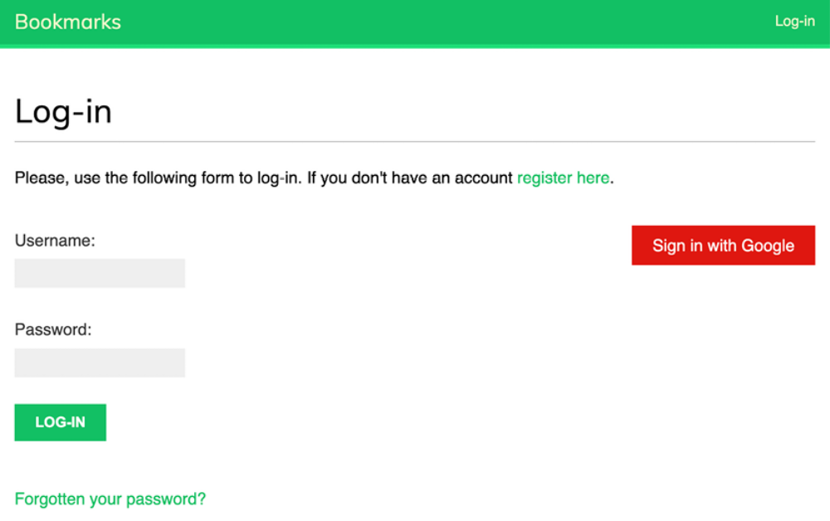
Figure 5.20: The login page including the button for Google authentication

Click on the Sign in with Google button. You will see the following screen:
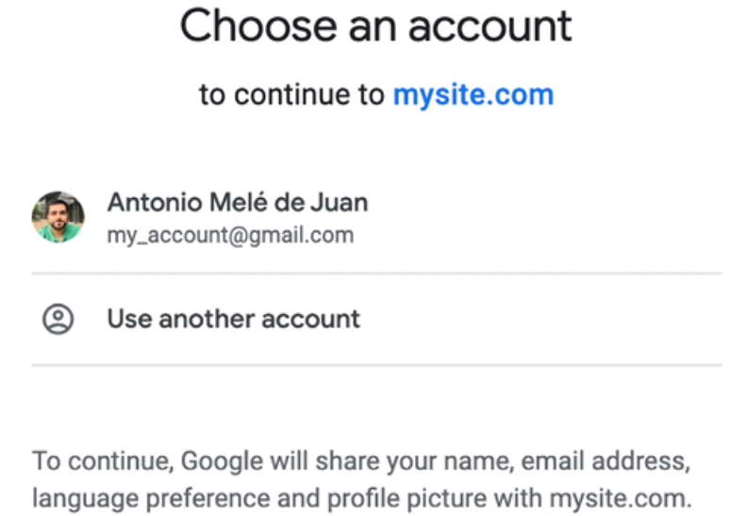
Figure 5.21: The Google application authorization screen

Click on your Google account to authorize the application. You will be logged in and redirected to the dashboard page of your site. Remember that you have set this URL in the LOGIN_REDIRECT_URL setting. As you can see, adding social authentication to your site is pretty straightforward.

You have now added social authentication to your project with Google. You can easily implement social authentication with other online services using Python Social Auth. In the next section, we will address creating user profiles when registering with social authentication.

Creating a profile for users that register with social
authentication
When a user authenticates using social authentication, a new User object is created if there isn’t an existing user associated with that social profile. Python Social Auth uses a pipeline consisting of a set of functions that are executed in a specific order during the authentication flow. These functions take care of retrieving any user details, creating a social profile in the database, and associating it with an existing user or creating a new one.

Currently, no Profile object is created when new users are created via social authentication. We will add a new step to the pipeline to automatically create a Profile object in the database when a new user is created.

Add the following SOCIAL_AUTH_PIPELINE setting to the settings.py file of your project:
SOCIAL_AUTH_PIPELINE = [
'social_core.pipeline.social_auth.social_details',
'social_core.pipeline.social_auth.social_uid',
'social_core.pipeline.social_auth.auth_allowed',
'social_core.pipeline.social_auth.social_user',
'social_core.pipeline.user.get_username',
'social_core.pipeline.user.create_user',
'social_core.pipeline.social_auth.associate_user',
'social_core.pipeline.social_auth.load_extra_data',
'social_core.pipeline.user.user_details',
]

This is the default authentication pipeline used by Python Social Auth. It consists of several functions that perform different tasks when authenticating a user. You can find more details about the default authentication pipeline at
https://python-socialauth.readthedocs.io/en/latest/pipeline.html.

Let’s build a function that creates a Profile object in the database whenever a new user is created. We will then add this function to the social authentication pipeline.

Edit the account/authentication.py file and add the following code to it:
from account.models import Profile
def create_profile(backend, user, *args, **kwargs):
"""
Create user profile for social authentication
"""
Profile.objects.get_or_create(user=user)

The create_profile function takes two required arguments:

- backend : The social auth backend used for user authentication. Remember that you added the social authentication backends to the AUTHENTICATION_BACKENDS setting in your project.

- user : The User instance of the new or existing authenticated user.

You can check the different arguments that are passed to the pipeline functions at https://python-socialauth.readthedocs.io/en/latest/pipeline.html#extending-the-pipeline.

In the create_profile function, we check that a user object is present and we use the get_or_create() method to look up a Profile object for the given user, and we create one if necessary.

Now, we need to add the new function to the authentication pipeline. Add the following line highlighted in bold to the SOCIAL_AUTH_PIPELINE setting in your settings.py file:
SOCIAL_AUTH_PIPELINE = [
'social_core.pipeline.social_auth.social_details',
'social_core.pipeline.social_auth.social_uid',
'social_core.pipeline.social_auth.auth_allowed',
'social_core.pipeline.social_auth.social_user',
'social_core.pipeline.user.get_username',
'social_core.pipeline.user.create_user',
'account.authentication.create_profile',
'social_core.pipeline.social_auth.associate_user',
'social_core.pipeline.social_auth.load_extra_data',
'social_core.pipeline.user.user_details',
]

We have added the create_profile function after social_core.pipeline.create_user . At this point, a User instance is available. The user can be an existing user or a new one created in this step of the pipeline. The create_profile function uses the User instance to look up the related Profile object and create a new one if necessary.

Access the user list in the administration site athttps://mysite.com:8000/admin/auth/user/ . Remove any users created through social authentication.

Then, open https://mysite.com:8000/account/login/ and perform social authentication for the user you deleted. A new user will be created and now a Profile object will be created as well. Access https://mysite.com:8000/admin/account/profile/ to verify that a profile has been created for the new user.

We have successfully added the functionality to create the user profile automatically for social authentication.

Python Social Auth also offers a pipeline mechanism for the disconnection flow. You can find more details at https://pythonsocialauth.readthedocs.io/en/latest/pipeline.html#disconnection-pipeline.

Summary
In this chapter, you significantly improved your social site authentication capabilities by creating an email-based authentication backend and adding social authentication with Google. You also improved the user experience by providing feedback for their actions using the Django messages framework.
Finally, you customized the authentication pipeline to create user profiles for new users automatically.

In the next chapter, you will create an image bookmarking system. You will learn about many-to-many relationships and customizing the behavior of forms. You will learn how to generate image thumbnails and how to build AJAX functionalities using JavaScript and Django.

Additional resources
The following resources provide additional information related to the topics
covered in this chapter: ( See page 390 )

